**Year 2 – Autumn 2 - Music – Call and response**

**What should I already know?**

we

**Key Vocabulary and Definitions**

M

* How to use my voice expressively and creatively by singing songs and speaking chants and rhymes.
* How to play tuned and untuned instrumentsmusically.
* How to show pulse and rhythm.
* To recognise the tempo of music and use the correct vocabulary to talk about the tempo.

|  |  |
| --- | --- |
| **Call and response** | One person sings or plays something and others sing or play something back, in reply. |
| **Dynamics** | The volume of a piece of music. |
| **Sound pattern** | When long and short sounds repeat in a certain way. |

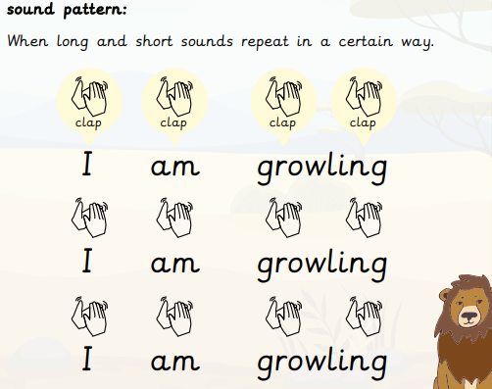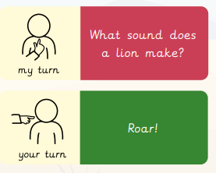

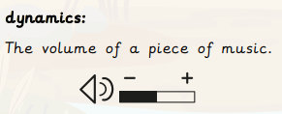

|  |  |
| --- | --- |
| Recognise and name some instruments. | To know that dynamics can change the effect a sound has on the audience. |
| Recognise simple patterns and repetition in rhythm. (e.g. where a pattern of beats is repeated). | To know how to experiment with adapting rhythmic patterns |

**Key Knowledge**