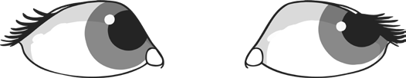

Look and say

Look, say and write

Cover and write

no

the

so

